**How to Test Program before you pay**

1. Open the folder containing program. You will find *Start_Program* .m file in it.

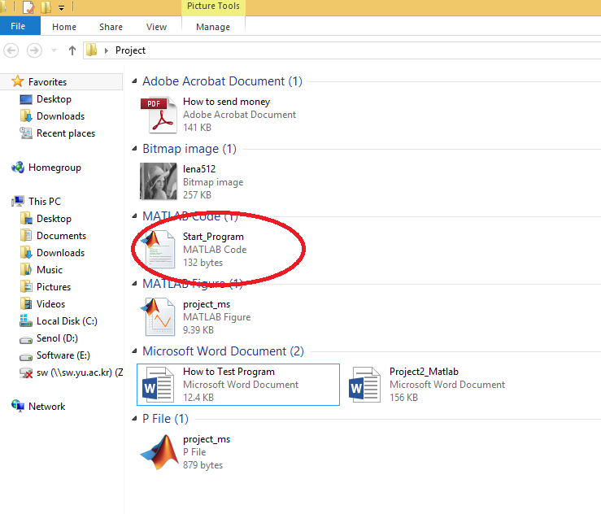

1. Double click this *Start_Program* file. It will open. Then run program by pressing green button.

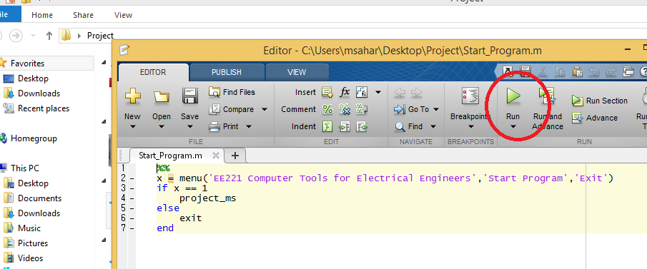

1. A menu will appear. Press start button to Start demo Program.

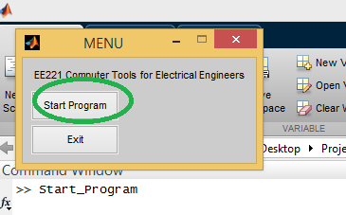

Note:

Actual Program with (.m) files and code will be sent to you when you sent me the money transfer receipt.

Thanks